Specific character of photorefractive keratectomy
performed by laser “Profile-500”
(by result of 9-year operation of the excimer laser installation “Profile-500”)

А.I. Myagkikh, Е.А. Subbotin, Е.V. Makurin, М.А. Maygkikh,
“Ost-Optic K Co., Ltd.”, Vladivostok

In 2000 at the VII ophthalmologists’ conference of Russia it was declared that the excimer laser installation of the fifth generation “Profile-500” was developed in Russia, which operates according to the unique technology (also developed in Russia) of photorefractive keratectomy (PRK) not requiring preoperative deepithelialization of the eye cornea /1/. Installations “Profile-500” amounting to fifteen were applied to perform PRK at branches of Inter-Branch Scientific and Technical Center “Eye Microsurgery” and some other domestic and foreign clinics. The results of refractive operation predicted in /1/ were embodied in some scientific papers, but were not widely discussed, not least because of the fact that cases of treatment and prevention of probable complications are subject to active concerned discussion in medical literature, which could not be obviously seen after operation of “Profile-500”. In addition, after the introduction of “Profile-500” into medical practice and relevant technology no political decision was taken concerning the registration of the official name of this variety of PRK, though a set of its distinctive features is rather impressive. Various publications named it: “super-PRK” /1/, “PRK on “Profile-500” /2/, PARK /3, 4/, “Progressive super-PRK” /5/, “Superficial PRK” /6/. Eventually, this situation brought to “ideological” confusion when results are “bulked”, which are reached on absolutely different installations, and they are considered as characteristics of PRK in common sense /7/. Such approach cannot be considered acceptable from the point of view of users of the installation “Profile-500”, since the material worked out and accumulated by the authors strongly demonstrates that many biases against the use of PRK have no sound grounds at the very least when the case in point is the use of this Russian technology.
In order to correctly discuss the materials and understand differences in the PRK performance technology the authors propose the following definition of the subject: “TECHNOLOGY OF TRANSEPITHELIAL PHOTOREFRACTIVE KERATECTOMY, WHEREIN A WORKING ELEMENT OF ACTION ON THE CORNEA IS EXCLUSIVELY IMPULSE MODULATED EXCIMER LASER RAY WHICH HAS THE WIDTH EQUAL TO THE WIDTH OF OPERATION ZONE, AND REGULATED GAUSSIAN RADIAL DISTRIBUTION OF ENERGY DENSITY IN CROSS-SECTION OF THE RAY”. The registered trademark – Trans-PRK®.
A physical pattern of action of “Profile-500” on the cornea is studied and considered in reasonable detail in /2/ and /3/. First clinical observations of some hundred of operated eyes are described in /4/. Therefore, without detailing the known things, let’s see how the new physical principles formed the basis of Trans-PRK® are expressed in results of operations. Materials are obtained in processing data for more than 5000 operations performed in Vladivostok by “Ost-Optic K Co., Ltd.” on the installation “Profile-500”.

1. Transepithelial effect — no need for preliminary mechanical stage of removal of epithelium. Due to this effect, the time of full epithelialization with Trans-PRK® is from 1,5 to 2 days without using any additional means to protect the corneal epithelium, which is about 2 as much than with PRK with mechanical or chemical removal of epithelium. Blepharospasm is observed not more than 2 days. In addition, moderately marked pain syndrome and safe operation enable to perform operation on both eyes. Since there is no mechanical damage to the epithelium we have a very even margin of operation field, which minimizes a probability of the occurrence of a mixed form of corneal syndrome /7/. This is aided by smoothness of the treated surface of the cornea, which is, first, a consequence of mechanical action on the epithelium and Bowman's membrane. Second, the action of a laser ray does not worsen the properties of the corneal surface since the ray has exclusive smoothness of profile of space distribution of energy density. The same factors reduce a risk of the development of superficial corneal opacity. Notwithstanding, arisen opacities in 36,8% cases take place independently, without any treatment. The absolute majority takes place after a course of resolve therapy is prescribed (Fig. 1, 2).
Trans-PRK®. Dimness arising
65,16%
3,10%
31,73%
Early & Slight (<3 months)
Later (> 4 months)
No dimness
Fig. 1. Trans-PRK®. Dimness arising

Different dimness – various periods
0,00%
5,00%
10,00%
15,00%
20,00%
25,00%
30,00%
35,00%
40,00%
1-3 months
More than 4 months
Postoperative period
Subepithelial opalescence
0,1 in center -
0,5 in center -
1,0 in center -
1,5 in center -
At all treated area
0,5 on edge of treated area
1,5 on edge of treated area
Fig. 2. Trans-PRK®. Different dimness – various periods

Kind of dimness | 1-3 months | More than 4 months
Subepithelial opalescence | 34,45% | 1,37%
0,1 in center | 0,00% | 0,05%
0,5 in center | 28,98% | 1,65%
1,0 in center | 0,05% | 0,00%
1,5 in center | 0,05% | 0,00%
At all treated area | 0,99% | 0,00%
0,5 on edge of treated area | 0,05% | 0,00%
1,5 on edge of treated area | 0,58% | 0,03%

Table for Fig. 2: Trans-PRK®. A summary table of dimness at various postoperative periods.

2. Wide ray. The whole point of using a wide ray is that every impulse contains full information on every parameters of action on the cornea, and a final refractive effect is determined only by the number of laser impulses. This fact brings to the front a possibility to stop the operation at any time, including in the case of a fault (it is important to record the number of passed impulses only), and then to continue the operation. It means that the operation may be performed in some stages as well as after another surgeries on the cornea, for example, keratomy. An interesting feature of Trans-PRK® is that the standard diameter of working zone is 6 - 8 mm (and more, when necessary). At that, a transitional zone of operation field to the optical visual zone is smooth, which excludes halo and glare effects. By the examples of postsurgical keratotopograms (Fig. 3, 4, 5) on the eyes with a various degree of initial myopia one may be vividly seen the smoothness of transitional zone, how the conditions for maintenance and increase of a functional optical zone are created. We would like to specifically note the absence of “central islands”. One more unhacked consequence of the use of the wide ray – there is no need for a high expensive system of tracking for the position of the patient’s pupil or any mechanisms fixing the eye position. The number of impulses of action is counted in hundreds and influence of casual minor eye movements (like saccade) for the time of operation is averaged up to complete absence. Significant (conscious) withdrawal of the pupil is immediately recorded by the doctor and the operation is stopped. In the company’s working practice there were some cases of such “emergency” stops of operation which not at the least affected the final result.

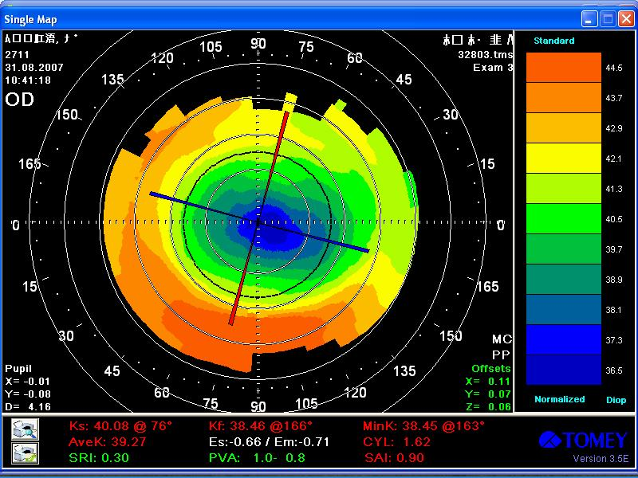
Fig. 3. Value of Correction Sph -3.25, Cyl -0.5, BSCVA before operation – 1.0, UCVA 9 days later – 0.8, Age – 22 years, Female

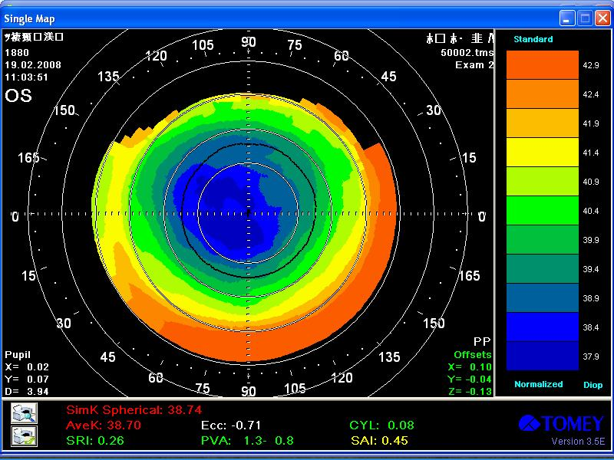
Fig. 4. Value of Correction Sph -6.0, BSCVA before operation – 0.9 UCVA 3 month later – 0.9, Age – 18 years, Female

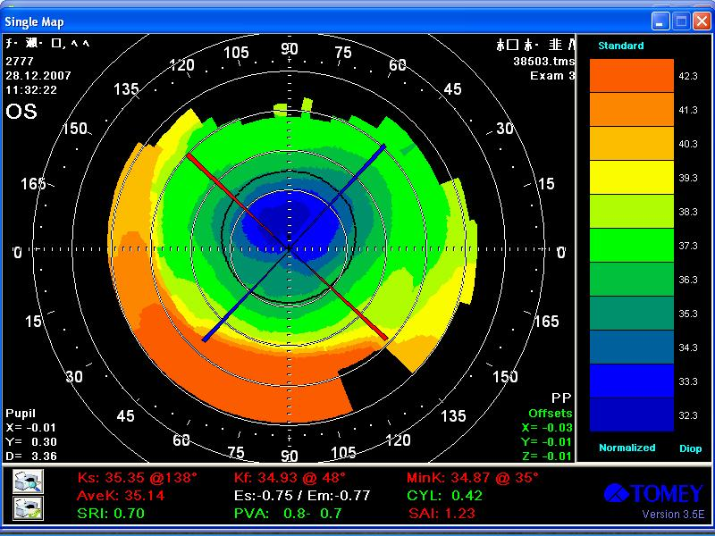
Fig. 5. Value of Correction Sph -10.0, BSCVA before operation – 0.8, UCVA 1.5 month later – 0.5, Age – 44 years, Female

3. Gaussian radial distribution of energy density of the laser ray. The nature of ablation of corneal stroma providing a refractive effect is such that thickness of a removed layer is proportional to logarithm of a laser ray energy density /2/. Thus, every impulse of laser which has Gaussian distribution of energy density removes “ideal lens” from the surface”. Ideal from the optical standpoint, since its surfaces are paraboloids of rotation. The initial surface of the cornea has just such form (if there is astigmatism – stretched over a week axis). This means that the action by method Транс-PRK® should not bring considerable distortions into eye optics as high-order aberrations /6/. A consequence of which, according to patients, “natural, normal” vision, including at night and at dusk. A choice of the parameter of width of Gaussian distribution enables on a single step to correct both very weak and super high myopia. On the company’s credit side there is a single-step correction of myopia from 0.75 to 17.0 D. The company’s absolute achievement – correction of 28 D myopia in several stages.
4. A possibility to choose energy density. Available nonlinear effect in the law of dependence of thickness of a layer of cornea ablation from energy density of a laser ray makes possible to reach monofocal and multifocal reprofiling on the cornea /1, 2/. In the event of definite choice of energy density in the center of laser ray, obtained optical profile is non-homogeneous in optical force. This phenomena is vividly demonstrated by the same examples of keratotopograms (Fig. 3, 4, 5). A bright distinctive feature of the obtained optical profile of the cornea — availability of physiological asphericity, i.e. monotonous growth of myopia towards to periphery of the optical zone. Such growth of myopia reduces a jump of optical force on the border of ablation zone and ensures a smooth transitional zone (see also item 2). In addition, the patients with a similar optical profile should feel so called “pseudoaccommodation” which enables to see better at various distances. It just not entirely obvious how to make exact optical measurements of this effect, therefore we should be satisfied with subjective replies of our patients and findings of keratotopograms. One again we underline that the effect of multifocal reprofiling is “automatically” achieved, i.e. the ray makes no special actions and mechanical manipulations, just a relevant value of energy density of the laser is chosen.

In Vladivostok, since 2004 “Ost-Optic К Co., Ltd.” has used an optimized version of the action of excimer laser on the cornea, as well as a corrected plan of rehabilitation treatment after performing the operation Trans-PRK®. This enabled to considerably increase the number of patients whose vision may be corrected at the expense of incorporating them into the number of patients with super high myopia, as well as with a low initial corrected visual acuity. For this reason, a direct evaluation of Trans-PRK® according to efficiency and safety criteria recommended by the FDA /9/ is not quite correct. For example, the number of operated eyes with initial corrected visual acuity less than 0.5 with the value of initial myopia over 12 D (Fig. 6) exceeds 50%.

BSCVA before operation
0,00%
20,00%
40,00%
60,00%
80,00%
0,1
0,2
0,3
0,4
0,5
0,6
0,7
0,8
0,9
1
<3D
3 – 6D
6 – 15D
>15D
Fig. 6. Trans-PRK®. BSCVA before operation

Under such conditions a criterion of absolute visual acuity after operation almost completely losses its presentability. In such, more common case, in order to correctly and vividly determine the efficiency (productivity) it is appropriate to use comparison with uncorrected visual acuity (UCVA) after operation with the best corrected visual acuity (BSCVA) before operation – as their mathematical ratio of efficiency coefficient /5, 8/. Efficiency of Trans-PRK® on a general basis of operation (i.e. without any exclusion of data) of “Ost-Optic K Co., Ltd.” as to conditions of eyes at least 1 year after operation is given in Fig. 7.

К рез = UCVA (postoperative) / BSCVA (before operation)
0,00%
10,00%
20,00%
30,00%
40,00%
50,00%
60,00%
70,00%
(0-0,2]
(0,2-0,4]
(0,4-0,6]
(0,6-0,8]
(0,8-1]
(1-1,2]
(1,2-1,4]
(1,4-1,6]
(1,6-1,8]
(1,8-2]
(2-2,2]
(2,2-2,4]
(2,4-2,6]
(2,6-2,8]
К рез →
<3D
3-6D
6-15D
>15D
Fig. 7. Trans-PRK®. Total result

Similarly, in order to correctly evaluate the results of work of Trans-PRK® based on a safety criterion /8, 9/, we excluded from the analysis of patients:
- where the operation was planned to be performed in two stages but the second stage was not performed for various reasons;
- undercorrection was planned according to age;
- process of postsurgical follow-up was less than 2 months;
- maximum visual acuity with correction before operation was less than 0.5.
In view of the above we see the following:

Initial myopia | Group 1  from -0,5 to -3,0 D | Group 2  from -3,25 to -5,75 D | Group 3  from -6,0 to -15,0 D | Group 4  over  -15,25 D
Number of eyes | N = 811 | N = 1726 | N = 1374 | N = 35
Received visual acuity without correction lower 0.5 | 1 eye | 8 eyes | 36 eyes | 3 eyes
Losses of maximum corrected visual acuity < 2 lines | 0 | 0 | 0 | 2 eyes*
Losses of maximum corrected visual acuity < 2 lines | 0 | 0 | 1 eye* | 1 eye*
* - eyes having losses of visual acuity not connected with refraction (detached retina, CNM).

Comparison of characteristics of various types of photorefractive keratectomy (PRK)
(Classical PRK –literary data, Trans-PRK® on “Profile-500”- based on the result of work of
“Ost-Optic К Co., Ltd.”, Vladivostok)
Criterion | “Classical” PRK | Trans-PRK® on “Profile-500”
Action sequence | - local anaesthesia  - deepithelization (mechanical, laser or other)  - refractive stage: laser treats the stroma (flying-spot scanning or ray profiling as geometric figures)  - placement of SCL (not always) | - local anaesthesia  - transepithelial treatment by a wide laser ray (radial Gaussian distribution of energy density over the whole zone of operation).
Pain syndrome after operation | The patient may feel strongly marked discomfort within 3-4 days. | Pain syndromes at the day of operation pass in 30% patients toward evening, next day they feel only photophobia and eyewatering. Two days later 91,5% patients have no any discomport.
Blepharospasm | 3-4 days | 1-2 days after operation
Time of putting drops after operation | Within 4-6 months it is necessary to put eye drops according to a special scheme selected depending on complexity of refraction in the patient before operation. | 1-2 months maximum irrespective of initial myopia
Drop composition | Steroid load – increase of intraocular pressure may be observed about in 5% patients. This effect is neutralized by medicines reducing the intraocular pressure, or a whole regimen of postsurgical treatment should be applied, which is a nonstandard situation. | Increase of intraocular pressure is noted rarer in view of reduction of the term of therapy, and medicines reducing the intraocular pressure are prescribed only if its increase effects the visual acuity.
Vision recovery | Vision begins to recover within 3–4 days | Next day toward evening the patient see about 30% of any possible, there is photophobia
Sport and driving | Within a month | Within 10-14 days
Computer and TV | Within a month | Within 10-14 days
Complications | Complications as opacities according to world statistics after PRK operation are 4 - 12%. Corneal opacities are strong and require long treatment which may distort refractive result. Even with the clear cornea, there may be a regress of myopia in the same figures depending on initial myopia. | Opacities are generally non-persistent, and they respond to standard treatment by using resolve therapy. A probability of regress is minor. Repeated operation to remove opacities and/or correct myopic regress for 9 years of the company’s work required 1,28% patients.
Dependence of intensity of opacities on degree of myopia | With initial myopia up to 6 D a percent of complications connected with corneal opacity is extremely low. As a degree of myopia of the operated patient increases a probability of corneal opacity considerably increases (up to 14 – 29%) (Eskina, 2002). | Dependence is weak but directly proportional: the higher degree of myopia – the higher probability of opacities.  At that, occurrence of subepithelial opalescence or fibroplasia in moderate severe and high myopia may be reveled at an early term in 77% patients, but less than a half of them needs treatment.
Occurrence of high-order aberrations | The occur frequently disturbing twilight and night vision | Do not occur
Rage of initial myopia | Up to minus 6 – 8 D | Not limited (single-step correction up to minus 17.0 D)
Procedure of correction | First, one eye, a week later – another eye | Both eyes at the same time
Received optical profile | Monofocal | Multifocal. Pseudoaccommodation may reach 3 D.

The authors express their thanks to S.K. Vartapetov and V.G. Movshev, employees of Physical Instrument-making Center at General Physics Institute of the Russian Academy of Science, for useful discussion and assistance in writing the article.

References:
1. Лазерная рефракционная хирургия. С.Н.Федоров, А.Д.Семенов, И.М.Корниловский, А.В.Дога, Г.Ф.Качалина. VII съезд офтальмологов России. Тезисы докладов. М., 2000 г., стр. 221-225.
2. Качалина Г.Ф. Хирургическая технология трансэпителиальной ФРК при миопии на эксимерлазерной установке «Профиль-500»: Автореф. дисс. канд. мед. наук. – М., 2000. – 25 с.
3. А.Д. Семенов, А.В. Дога, Г.Ф. Качалина и др. Фотоастигматическая рефрактивная кератэктомия на установке «Профиль-500» в коррекции сложного миопического астигматизма // Офтальмохирургия. - 2000. - № 4. - с. 3-8.
4. А.Д. Семенов, А.В. Дога, Г.Ф. Качалина и др. Особенности клинического течения фотоастигматической рефрактивной кератэктомии на установке «Профиль-500» в различные сроки после операции // Офтальмохирургия. - 2001. - № 1. - с. 3-7.
5. Методика определения качества рефракционных операций. А.И.Мягких. «Федоровские чтения – 2002»: сборник научных статей п/ред. Х.П.Тахчиди, - М., 2002, стр. 246-248.
6. Суперфициальная ФРК. Окуяма Кодо, Галина Качалина и др. Тезисы докладов VIII Съезда офтальмологов России, М., 2005 г. стр. 262-263.
7. Особенности отбора пациентов и проведения эксимерлазерных операций в лечебных учреждениях МО РФ: Методические рекомендации, - М:, ГВКГ им. Н.Н. Бурденко, 2003 г., - 42 с.
8. Осложнения ЛАСИК: анализ 12500 операций. К.Б. Першин, Н.Ф. Пашинова. Клиническая офтальмология, т. 1, № 4, 2001 г.
9. Checklist of Information Usually Submitted in an Investigational Device Exemptions (IDE) Application for Refractive Surgery Lasers. U.S Department Of Health And Human Services. Food and Drug Administration. 1996.

